Project Planning Phase

**Project Planning Template (Product Backlog, Sprint Planning, Stories, Story points)**

|  |  |
| --- | --- |
| Date | 08November2022 |
| Team ID | PNT2022TMID07659 |
| Project Name | Fertilizer Recommendation System for Disease  Prediction |
| Maximum Marks | 8 Marks |

Product Backlog, Sprint Schedule, and Estimation (4 Marks)

|  |  |  |  |  |  |  |
| --- | --- | --- | --- | --- | --- | --- |
| **Sprint** | **Functional**  **Requirement**  **(Epic)** | **User Story**  **Number** | **User Story / Task** | **Story**  **Points**  **(Total)** | **Priority** | **Team**  **Members** |
| Sprint-1 | Model Creation and Training  (Fruits) |  | Create a model which can classify diseased fruit plants from given images. I also need to test the  model and deploy it on IBM Cloud | 8 | High | Harish kumar.R, Vignesh.P, Pavithran.V, Akash.J |
|  | Model Creation and  Training (Vegetables) |  | Create a model which can classify diseased  vegetable plants from given images | 2 | High | Pavithran.V,  Harish kumar .R Vignesh.P, Akash.J |

|  |  |  |  |  |  |  |
| --- | --- | --- | --- | --- | --- | --- |
| **Sprint** | **Functional**  **Requirement**  **(Epic)** | **User Story**  **Number** | **User Story / Task** | **Story**  **Points**  **(Total)** | **Priority** | **Team Members** |
| Sprint-2 | Model Creation  and Training (Vegetables) |  | Create a model which can classify diseased  vegetable plants from given images and train on IBM Cloud | 6 | High | Vignesh.P, Pavithran.V,  Akash.J, Harish kumar.R |
|  | Registration | USN-1 | As a user, I can register by entering my email,  password, and confirming my password or via OAuth API | 3 | Medium | Harish kumar.R,  Vignesh.P, Pavithran.V, Akash.J. |
|  | Upload page | USN-2 | As a user, I will be redirected to a page where I  can upload my pictures of crops | 4 | High | ,Akash.J,  Harish kumar.R, Vignesh.P, Pavithran.V, |
|  | Suggestion results | USN-3 | As a user, I can view the results and then obtain  the suggestions provided by the ML model | 4 | High | Harish kumar.R, Vignesh.P, Pavithran.V,  Akash.J |
|  | Base Flask App |  | A base Flask web app must be created as an  interface for the ML model | 2 | High | Harish kumar.R, Vignesh.P, Pavithran.V,  Akash.J |
| Sprint-3 | Login | USN-4 | As a user/admin/shopkeeper, I can log into the  application by entering email & password | 2 | High | Harish kumar.R, Vignesh.P, Pavithran.V,  Akash.J |
|  | User Dashboard | USN-5 | As a user, I can view the previous results and  history | 3 | Medium | Harish kumar.R,  Vignesh.P, Pavithran.V, Akash.J |
|  | Integration |  | Integrate Flask, CNN model with Cloudant DB | 5 | Medium | Harish kumar.R,  Vignesh.P, Pavithran.V, Akash.J |

|  |  |  |  |  |  |  |
| --- | --- | --- | --- | --- | --- | --- |
|  | Containerization |  | Containerize Flask app using Docker | 2 | Low | Harish kumar.R, Vignesh.P, Pavithran.V,  Akash.J |
|  |  |  |  |  |  |  |
| Sprint-4 | Dashboard  (Admin) | USN-6 | As an admin, I can view other user details and  uploads for other purposes | 2 | Medium | Harish kumar.R,  Vignesh.P, Pavithran.V, Akash.J |
|  | Dashboard  (Shopkeeper) | USN-7 | As a shopkeeper, I can enter fertilizer products  and then update the details if any | 2 | Low | Harish kumar.R, Vignesh.P, Pavithran.V,  Akash.J |
|  | Containerization |  | Create and deploy Helm charts using Docker  Image made before | 2 | Low | Harish kumar.R,  Vignesh.P, Pavithran.V,  Akash.J |

Project Tracker, Velocity & Burndown Chart: (4 Marks)

|  |  |  |  |  |  |  |
| --- | --- | --- | --- | --- | --- | --- |
| **Sprint** | **Total Story**  **Points** | **Duration** | **Sprint Start Date** | **Sprint End Date**  **(Planned)** | **Story Points**  **Completed (as on Planned End Date)** | **Sprint Release Date**  **(Actual)** |
| Sprint-1 | 10 | 6 Days | 24 Oct 2022 | 29 Oct 2022 | 10 | 30 Oct 2022 |
| Sprint-2 | 15 | 6 Days | 31 Oct 2022 | 05 Nov 2022 | 15 | 06 Nov 2022 |
| Sprint-3 | 15 | 6 Days | 07 Nov 2022 | 12 Nov 2022 | 15 | 13 Nov 2022 |
| Sprint-4 | 12 | 6 Days | 14 Nov 2022 | 19 Nov 2022 | 10 | 20 Nov 2022 |

***NOTE: Burndown charts, Velocity to be updated dynamically after end of sprints***

Roadmap:

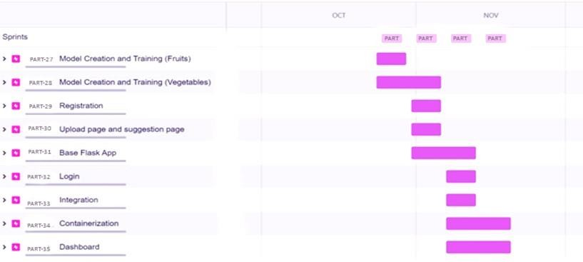

Screenshots:

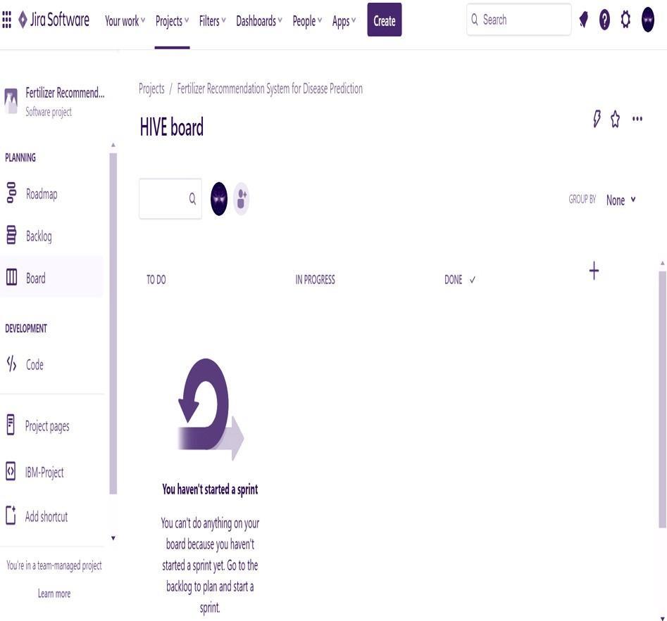

**PART Board**

